Project Synopsis

on

**Traffic Sign Recognition**

Submitted as a part of course curriculum for

**Bachelor of Technology**

in

**Computer Science**



**Submitted by**

Asish Kumar(2000290120046)

Prashant Gupta(2000290120111)

Anubhav Kumar(2000290120032)

**Under the Supervision of**

Mr. Pawan kumar Pal

Asst. professor (CS)

**KIET Group of Institutions, Ghaziabad**

**Department of Computer Science**

**Dr. A.P.J. Abdul Kalam Technical University**

**2022-2023**

**DECLARATION**

We hereby declare that this submission is our work and that, to the best of our knowledge and belief, it contains no material previously published or written by another person nor material which to a substantial extent has been accepted for the award of any other degree or diploma of the university or other institute of higher learning, except where due acknowledgement has been made in the text.

Signature of Students

Name: Asish Kumar Anubhav Kumar Prashant Gupta

Roll No.: (2000290120046) (2000290120032) (2000290120111)

Date: March 10, 2024

**CERTIFICATE**

This is to certify that Project Report entitled “**Traffic sign Recognition**” which is submitted by **Asish kumar, Prashant Gupta and Anubhav Kumar** in partial fulfilment of the requirement for the award of degree B. Tech. in Department of Computer Science of Dr A.P.J. Abdul Kalam Technical University, Lucknow is a record of the candidates own work carried out by them under my supervision. The matter embodied in this report is original and has not been submitted for the award of any other degree.

**Date: 10th march 2024 Supervisor Signature**

Mr. Pawan Kumar Pal

(Asst. professor)

**ACKNOWLEDGEMENT**

It gives us a great sense of pleasure to present the synopsis of the B.Tech Major Project undertaken during B.Tech. final Year. We owe a special debt of gratitude to Mr. Pawan Kumar Pal (Asst. Prof ), Department of Computer Science, KIET Group of Institutions, Delhi- NCR, Ghaziabad, for his/her constant support and guidance throughout the course of our work. His sincerity, thoroughness and perseverance have been a constant source of inspiration for us. It is only his/her cognizant efforts that our endeavours have seen the light of the day.

We also take the opportunity to acknowledge the contribution of Dr. Ajay Kumar Shrivastava, Head of the Department of Computer Science, KIET Group of Institutions, Delhi- NCR, Ghaziabad, for his full support and assistance during the development of the project. We also do not like to miss the opportunity to acknowledge the contribution of all the faculty members of the department for their kind assistance and cooperation during the development of our project.

Last but not the least, we acknowledge our friends for their contribution to the completion of the project.

Signature:

Date :

Name :

Roll No:

**ABSTRACT**

Traffic Sign Recognition (TSR) is an important part of the driver support functions needed to make intelligent vehicles. The automatic system for classification of traffic signs is a critical task of an Advanced Driver Assistance Systems (ADAS) and a fundamental technique utilized as integral part to the various vehicles. The recognizable features of a traffic image are utilized for their classification. Traffic signs are designed in such a way that they contain specific shapes and colors, with some text and some symbols with high contrast to the background.

In this project, we proposed hybrid approach for classification of traffic signs by SIFT for image feature extraction and SVM for classification. The proposed work is divided into different phases like Feature Extraction and Classification Phase. MATLAB is used for the implementation purpose of proposed framework and classification is carried out by utilizing real traffic sign images.

**CHAPTER – 1**

**1.1 INTRODUCTION**

Traffic sign detection and recognition have received an increasing interest in the last years. This is due to the wide range of applications that a system with this capability provides, like Driving Assistance System. This is an attempt to make a self learning system that can itself understand and interpret the meaning of new traffic signs**.**

Road signs have many discriminating features on the basis of which they are

classiﬁed. According to their shapes and colours, these are ﬁve main classes:

warning signs (red triangle), prohibition signs (red circular), reservation

signs(rectangular blue), mandatory signs (circular blue), and temporary signs

(yellow triangle).

The main issue of the problem in the trafﬁc sign recognition system is not

how to detect or recognize, with high recall, a trafﬁc sign in a ﬁxed image. It is rather about how to obtain high precision in videos big data.

**1.2 PROBLEM STATEMENT**

The main idea of the traffic sign recognition project is to identify a traffic sign from a plate and digital photograph. The purpose of the model is to help the drivers by continuously monitoring and recognizing the traffic signs and recommending actions to the drivers and in ADAS (Advanced driver assistance systems) cars can perform certain actions by itself.

The sign may be viewed from various angles and in many diverse background situations.

Traffic sign will then be highlighted after identification and classify signs with a high accuracy rate. All image processing algorithm will be done in MATLAB.

**1.3 OBJECTIVE**

With the help of this project following objectives can be achieved:-

* Check the presence and condition of signs along major roads.
* Creating an inventory of signs in city environments.
* Assist the driver by informing of current restrictions, limits, and warnings.
* Any autonomous car that is to drive on public roads must have a means of obtaining the current traffic regulations. This can be done through TSR.

**1.4 SCOPE**

By studying / discussing with the team members it was found that our project can be use for recognizing the traffic sign. However it can be added to the following projects:-

* Advanced Driver Assistant Systems.
* Fully Autonomous Vehicles
* Tom Tom's Highly Automated driving car project

**CHAPTER – 2**

**2.1 LITERATURE REVIEW**

**Road-Sign Detection and Recognition Based on Support Vector Machines**

By: Saturnino Maldonado-Bascon and Sergio Lafuente-Arroyo

This paper presents an automatic road-sign detection and recognition system based on support vector machines (SVMs). In automatic traffic-sign maintenance and in a visual driver-assistance system, road-sign detection and recognition are two of the most important functions. This system is able to detect and recognize circular, rectangular, triangular, and octagonal signs. The proposed recognition system is based on the generalization properties of SVMs. The system consists of three stages: 1) segmentation according to the color of the pixel; 2) traffic-sign detection by shape classification using linear SVMs; and 3) content recognition based on Gaussian-kernel SVMs.

Traffic signs have a dual role: Firstly, they regulate the traffic and, second, indicate the state of the road, guiding and warning drivers. These signs can be classified according to their color and shape. The visibility of traffic signs is crucial for the drivers safety.

# Machine Vision Based Traffic Sign Detection Methods

# By : Shuang Li, Faliang Chang and Yinhai Wang.

Traffic signs recognition (TSR) is an important part of some advanced driver-assistance systems (ADASs) and auto driving systems (ADSs). We divide the reviewed detection methods into five main categories: color-based methods, shape-based methods, color- and shape-based methods, machine-learning-based methods, and LIDAR-based methods. The methods in each category are also classified into different subcategories for understanding and summarizing the mechanisms of different methods.

The color based methods are often fast and relatively simple. Shape based methods are often not suitable for detecting traffic signs with small size. The LIDAR(Light Detection and Ranging) based methods have large potential to handle these conditions. Extreme weather has a great impact on the quality of the images captured by cameras.

**ADAS and Video Surveillance Analytics System Using Deep**

**Learning Algorithms on FPGA**

By: YI SHAN

Deep learning algorithms, such as CNN (Convolutional Neural Network), can provide high accuracy for great number of applications including ADAS (Advanced Driver Assistance System) and video surveillance analytics. Considering processing speed and energy efficiency, FPGA is a good hardware to construct customized CNN solution.

Using this technology we want to benefit from hardware technology, and show a fast speed and accurate video analytics system using state-of-the-art deep learning algorithms running on low power FPGA. Field Programmable Gate Arrays (FPGAs) are semiconductor devices that are based around a matrix of configurable logic blocks (CLBs) connected via programmable interconnects.

ADAS technology is used for advancement in the field of surveillance and for traffic as well as symbol recognition systems. This is mainly used in the cars and other smart devices for detection of symbols and act according to it. Consider a ‘breaker’ symbol on the road sides after recognizing that symbol the car will automatically slow and similar cases can be observed for various symbols.

**Scaling Up Machine Learning**

Author: Ron Beckerman

Distributed and parallel processing of very large datasets has been employed for decades in specialized, high-budget settings, such as financial and petroleum industry applications.

The current rise in interest in scaling up machine learning applications can be partially attributed to the evolution of hardware architectures and programming frameworks that make it easy to exploit the types of parallelism realizable in many learning algorithms.

Several platforms make it convenient to implement concurrent processing of data instances or their features. This allows straight forward parallelization of many learning algorithms that view input as an unordered batch of examples and aggregate isolated computations over each of them.

Increased attention to large-scale machine learning is also due to the spread of very large datasets across many modern applications. Such datasets are often accumulated on distributed storage platforms, motivating the development of learning algorithms that can be distributed appropriately.

Finally, the proliferation of sensing devices that perform real-time inference based on high-dimensional, complex feature representations drives additional demand for utilizing parallelism in learning-centric applications.

**A Survey on Machine Learning: Concept, Algorithms and Applications**

by-Kajeera Das, R.Brehera

Machine Learning (ML) has evolved from the endeavour of few computer enthusiasts exploiting the possibility of computers learning to play games, and a part of Mathematics (Statistics) that seldom considered computational approaches, to an independent research discipline that has not only provided The necessary base for statistical-computational principles of learning procedures, but also has developed various algorithms that are regularly used for text interpretation, pattern recognition, and a many other commercial purposes and has led to a separate research interest in data mining to identify hidden regularities or irregularities in social data that growing by second. This paper focuses on explaining the concept and evolution of Machine Learning, some of the popular Machine Learning algorithms and try to compare three most popular algorithms based on some basic notions. Sentiment140 dataset was used and performance of each algorithm in terms of training time, prediction time and accuracy of prediction have been documented and compared. Human population growth in the developing world drives land-use changes, impacting food security. In India, the dramatic change in demographic dynamics over the past century has reduced traditional agricultural land-use through increasing commercialization.

**Machine Learning in Computer Vision**

by-Asharul Islam Khan a*, Salim Al-Habsib

The western countries have shown great interest on the topic of machine learning, computer vision, and pattern recognition via organizing conferences, workshops, collective discussion, experimentation, and real life implementation. This study on machine learning and computer vision explores and analytically evaluates the machine learning applications in computer vision and predicts future prospects. The study has found that the machine learning strategies in computer vision are supervised, un-supervised, and semisupervised. The commonly used algorithms are neural networks, k-means clustering, and support vector machine. The most recent applications of machine learning in computer vision are object detection, object classification, and extraction of relevant information from images, graphic documents, and videos images. The machine learning and computer vision hopes to bring into the computers the human capabilities for data sensing, data understanding, and action taking based on the past and present outcomes. The machine learning and computer vision research is still evolving [1]. Computer vision is an essential part of Internet of Things, Industrial Internet of Things, and brain human interfaces. The complex human activities are recognized and monitored in multimedia streams using machine learning and computer vison. There are numbers of well-established methods for prediction and analysis such as supervised learning, un-supervised learning, and semi supervised learning. These methods uses the machine learning algorithms such as support vector machine, KNN etc

**Traffic Sign Recognition System (TSRS): SVM and Convolutional Neural Network**

By-Nazmul Hasan, Tanvir Anzum, *Nusrat Jahan

. TSRS (Traffic Sign Recognition System) may plays a significant role in self driving car, artificial driver assistances, traffic surveillance as well as traffic safety. Traffic sign recognition is necessary to overcome the traffic related difficulties. The traffic sign recognition system has two parts localization and recognition. In localization part, where traffic sign region is located and identified by creating a rectangular area. After that, in recognition part the rectangular box provided the result for which traffic sign is located in that particular region. In this paper, we describe an approach towards traffic signs recognition system. Here, we worked on 12 selected sign to traffic sign detection and recognition purpose. In this intention, we used Support Vector Machine (SVM) and Convolutional Neural Metwork (CNN) individually to detect and recignize the traffic signs. We obtained 98.33% accuracy for SVM with 80:20 train and test data ratio. On the other hand, the test result was 96.40% accurate for CNN.

**CHAPTER – 3**

**3.1 PROPOSED METHODOLOGY**

1] A. Nikonorov, P. Yakimov, M. Petrov, Traffic sign detection on GPU using color shape regular expressions, VISIGRAPP IMTA-4, Paper 8

(2013).

[2] R. Belaroussi, P. Foucher, J.P. Tarel, B. Soheilian, P. Charbonnier, N. Paparoditis, Road Sign Detection in Images, A Case Study, 20th

International Conference on Pattern Recognition (ICPR), 2010, pp. 484-488

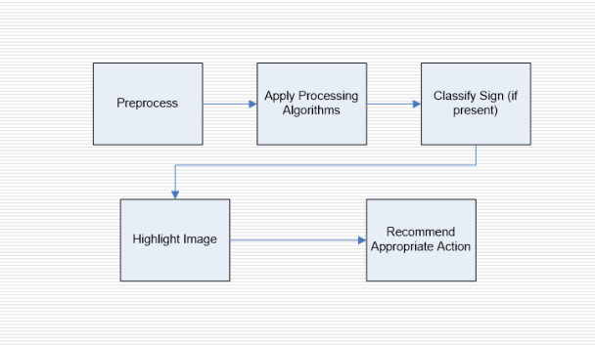

*Fig 3.1- flowchart*

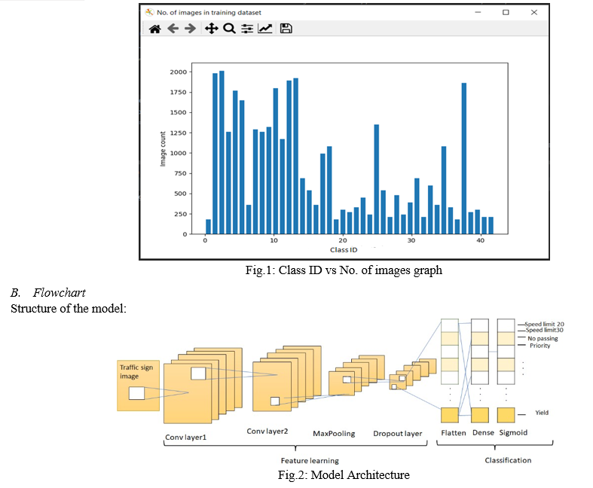

*Fig 3.2- Structure of model*

**3.2 ALGORITHM**

**Convolutional neural network (CNN) :**

A convolutional neural network, or CNN, is a deep learning neural network sketched for processing structured arrays of data such as portrayals.

CNN are very satisfactory at picking up on design in the input image, such as lines, gradients, circles, or even eyes and faces.This characteristic that makes convolutional neural network so robust for computer vision.

CNN can run directly on a underdone image and do not need any preprocessing.A convolutional neural network is a feed forward neural network, seldom with up to 20.The strength of a convolutional neural network comes from a particular kind of layer called the convolutional layer.

CNN contains many convolutional layers assembled on top of each other, each one competent of recognizing more sophisticated shapes.

**Steps to Implement**

1. Sequentially add the layers in the order: two convolutional layers, one pooling layer, dropout layer, flattening layer, dense layer, again a dropout layer and finally the dense layer.
2. In the convolutional layer, number of filters is specified. It performs the convolution operation on the original image and generates a feature map.
3. The ReLU performs the maximum function to convert the negative values to zero without changing the positive ones and generate a rectified feature map. The Pooling layer takes the rectified feature map and performs a down-sampling operation (like Max Pooling or average pooling) and thus reduces the dimensionality of the image.
4. The flattening layer is used to convert the input feature map to a 1-dimensional array.
5. The dropout layer is used to avoid over fitting by setting some of the input neurons to 0 during the training process. The dense layer, on the other hand, feeds all the outputs from the preceding layer to all its neurons and perform the matrix- vector multiplication (the row vector of the output from the preceding layer should be equal to the column vector of the dense layer), to generate a m-dimensional vector.
6. After addition of the layers, the model is to be compiled (final step in the creation of model to define the loss function and apply optimization techniques) and assign the loss function as “sparse_categorical_crossentropy” and use the “Adam optimizer”. The reason for specifying this loss function is that the proposed system is a multiclass classification problem, where multiple classes are considered but one image belongs to exactly one class.
7. Next, the model is trained using the training dataset, by passing the pre-processed images from the training dataset.
8. Finally, the predictions on the test data are done using the trained model and the traffic sign name along with the class Id is shown as an output

**CHAPTER-4**

**4.1 DIAGRAMS**

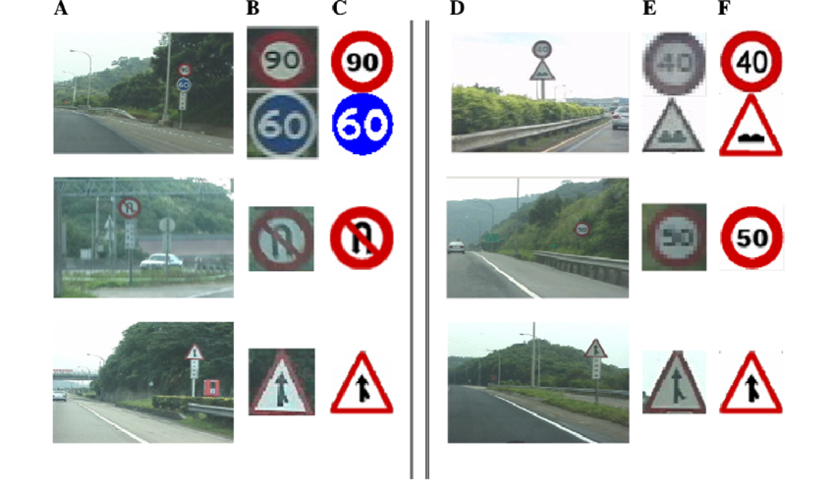

*Fig 4.1- Experimental Results*

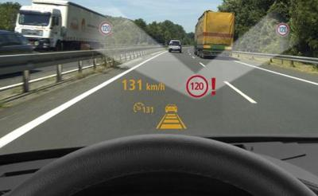

*Fig 4.2 – Working of model*

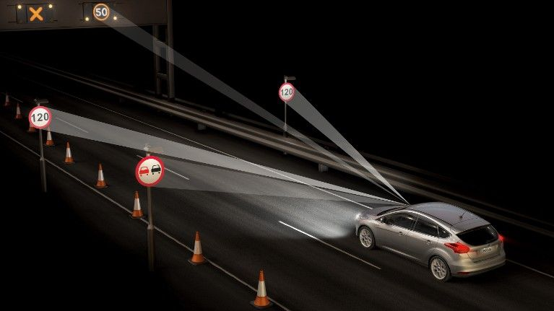

*Fig 4.3- Demonstration of model in real life*

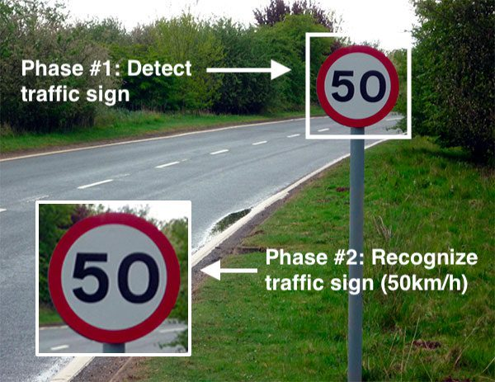

*Fig 4.4 – Phases of working of model*

**CHAPTER -5**

**5.1 CONCLUSION**

The algorithm that has been used for traffic signs it can be generalized to deal with other kinds of objects. The known difficulties that exist for object recognition in outdoor environment have been considered. This way the system is immune to lighting changes, occlusions and object deformation being useful for driver support systems.

Due to this knowledge of the sign status, it is believed that the system is useful for other applications such as maintenance and inventories of traffic sign in highway and cities.

**REFERENCES**

[1] A. Nikonorov, P. Yakimov, M. Petrov, Traffic sign detection on GPU using color shape regular expressions, VISIGRAPP IMTA-4, Paper 8 (2013).

[2] R. Belaroussi, P. Foucher, J.P. Tarel, B. Soheilian, P. Charbonnier, N. Paparoditis, Road Sign Detection in Images, A Case Study, 20th International Conference on Pattern Recognition (ICPR), 2010, pp. 484-488

[3] Aditya, A.M., & Moharir, S. (2016). Study of Traffic Sign Detection and Recognition Algorithms.

[4] Mogelmose, M. M. Trivedi and T. B. Moeslund, "Vision-based traffic sign detection and analysis for intelligent driver assistance systems: Perspectives and survey", *IEEE Trans. Intell. Transp. Syst.*, vol. 13, pp. 1484-1497, Dec. 2012.

[5] P. Viola and M. J. Jones, "Robust real-time face detection", Int. J. Comput. Vis., vol. 57, no. 2, pp. 137-154, 2004.

[6]L. Fletcher, N. Apostoloff, L. Petersson and A. Zelinsky, "Vision in and out of vehicles", *IEEE Intell. Syst.*, vol. 18, no. 3, pp. 12-17, May/Jun. 2003

[7] S. Lafuente-Arroyo, P. Gil-Jimnez, R. Maldonado-Bascn, F. Lpez-Ferreras and S. Maldonado-Bascn, "Traffic sign shape classification evaluation I: SVM using distance to borders", Proc. IEEE Intell. Veh. Symp., pp. 557-562, 2005-Jun.

[8] V. Balali, A. A. Rad and M. Golparvar-Fard, "Detection classification and mapping of U.S. traffic signs using Google street view images for roadway inventory management", Vis. Eng., vol. 3, no. 1, pp. 15, 2015.

[9] K. C. P. Wang, Z. Hou and W. Gong, "Automated road sign inventory system based on stereo vision and tracking", Comput.-Aided Civil Infrastruct. Eng., vol. 25, no. 6, pp. 468-477, 2010.

[10] V. Balali and M. Golparvar-Fard, "Evaluation of multiclass traffic sign detection and classification methods for U.S. roadway asset inventory management", J. Comput. Civil Eng., vol. 30, no. 2, 2016

|  |
| --- |
|  |